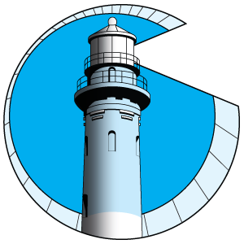
THE LIGHTHOUSE
Shining light on post-polio health

Coastal Empire Polio Survivors Association, Inc
P.O. Box 14355
Savannah, GA 31416

June, 2022 Newsletter www.coastalempirepoliosurvivors.org Vol. XXV, No. 3

The President’s Message

Good progress has been made dealing with the pandemic which has prevented our live meetings for two years. We are working on plans for a live lunch meeting on July 23, 2022, from 1:00-3:00. The location will be announced as soon as the details are finalized. Our meeting place will accommodate our special needs as a group. Save the date and be ready to make a firm reservation in the next two weeks. Lunch will be free for members with donations always welcome.
Our newsletter will celebrate two more CEPSA members as we share the personal polio survivor stories of Richard Graham and Beverly Jarvis in this issue. This year’s focus on our history books full of 25 years of memories has given joy beyond words. Diane Davis, CEPSA historian, has prepared two beautiful volumes of polio stories for posterity. They will be on display at the July 23rd meeting. If you are not represented in them, we would love to include your story in volume three. Just write it up and send it to me or Diane. What a treasure we have!
***************************************************************************
Member News from the mailbox and phone
Dan has made the difficult decision to give up driving. He plans to keep his adapted car and use drivers when he needs to go out. His caregiver next door will serve as his driver. He is doing well.
Tom Newcomer moved to a new apartment in Jesup. He is close to his church, the hospital, restaurants, and shopping. He uses a walker now, but he still drives. He is doing well.
Sandra Bath is enjoying a cruise in the Mediterranean Sea with her sister Diane.
Diane Davis has two new grandbabies in the family. She shares pictures on Facebook. She’s had some brace troubles, but she’s doing better.
Judy Frick Pebley is still unpacking in her new home. She loves the newsletter. She sends greetings and hugs to us all.
Casi R. Fisher loves to write cards which often include cartoons to share a smile. She writes, “I feel connected to all of you. We each have our unique story about polio. I wear the survivor label with great pride and honor. Stay safe and healthy. I love the newsletter!”

Let us hear from you.
Call each other.
Be well. Do good work. Keep in touch.
Marty Foxx President

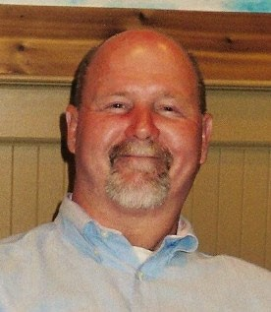
Richard Graham’s Personal Polio Story
Part 1
I was born in Savannah on May 31, 1954, the fourth child in my family with three older sisters. At that time polio was making its mark as a very serious disease. My parents had heard about the polio vaccine, but they opted not to have their children vaccinated fearing side effects. Around my first birthday, I became very ill and was admitted to Candler Hospital where my parents were told I had the polio virus. My treatment included being placed in an iron lung for a time. I was paralyzed from the neck down; the virus even took away my ability to cry out loud. When my condition stabilized, I was released to go home. My parents didn’t know what to do with me; they wrapped me in boiling hot towels and did the best they could. The doctor finally told them I’d be ok, except that one leg would be quite a bit shorter than the other.
That eventually affected my hip and back. My long-term care was given at the Crippled Children’s Clinic in Savannah. The doctors there preformed six surgeries, including one to slow the growth of my good leg by snipping something in the back of my knee. The “catch-up” theory did not work. By the time that was done, I was 15 and most of my growing had already happened. I thank God for the treatments that I received and for all the people who helped me along the way.
So this little guy grew up and as a teenager, I realized that those leg braces and special shoes weren’t so cool. I didn’t like them, so I decided to be like everybody else and get a pair of wingtips. My dad said that if I could walk in them, I could have them. I got my new shoes and learned to adjust.
My dad was an automobile painter and owned his own business. He taught me the trade, and I continued it for 28 years. I operated my own business, Richard’s Paint and Body Shop, beginning April 1, 1974.
In 1970 I met a very special girl, Linda, who was only 13. I was 16. We dated for a while and then got married in 1972. Everyone asked, “What were ya’ll thinking?” We weren’t!! But ultimately God had a special plan in mind. In March of 1973, Crystal Gail was born, and in October of 1976, Linda gave birth to Cynthia Marie. They both married wonderful husbands and have two children each, living close by Linda and me. We will celebrate our 50th wedding anniversary in 2022. My family is what drives me to keep going each day. God has truly blessed my life. If I go the rest of my days without another thing, I can’t complain, because I believe I have had my share of God’s wonderful blessings.

Richard’s post-polio syndrome challenge Part 2
After Richard and Linda married in their teens, Richard managed to buy a home and open his own body shop. Even with two daughters, he was successful enough repairing wrecked cars that his wife didn’t have to work. He attended his children’s school functions and ball games, and if the family went on an outing that required extensive walking, he’d bring his crutches. If it was a really long walk, his crutches would leave blisters on both hands. By 1997, he began to hurt in his “good knee” and he didn’t know why. He was told to exercise more and had two weeks of physical therapy at Candler, but what he was doing did not help his pain.
After therapy was ruled out as a remedy, another doctor performed knee surgery to repair what was probably a torn tendon. The doctor told Linda: “I don’t know what is wrong with him, but there is nothing wrong with his knee.” Even though Linda asked several doctors if they thought his ailment had anything to do with his childhood case of polio, that idea was brushed aside. His first doctor had said he had tumors in his leg, one the size of a fist. An operation to remove the tumors was not recommended because it could cause damage to the nerves and leave the ”good leg” as ineffectual as the paralyzed one. Richard could not risk that. He still did not

know what he had done to hurt himself, and he didn’t know what to do to make it better. Richard’s daughter found information on the Coastal Empire Polio Survivors Association on the Internet. His wife Linda called Cheryl Brackin to discuss Richard’s condition. Cheryl referred them to Dr. Paul Peach. Richard learned from Dr. Peach that there was nothing he could do to regain his strength. He encouraged Richard to conserve what strength there is left. Conserve to preserve. He came to realize that as he ages, he will lose even more strength. Dr. Peach finally convinced Richard that he needed a scooter instead of hauling his body around with his shoulders on crutches. It was not an easy decision for an admittedly stubborn man who didn’t think of himself as THAT disabled. Pain is the professor in the Reality 101 classroom. Finally, he got to the point of admitting he needed a scooter.
Richard’s insurance company took a longer time than he did to reach that conclusion however. In February he picked out a scooter and a chairlift for $5500 and he contacted his insurance agent about it. In late September he finally got an authorization letter, but not a check. First, it had to be sent off for review. Other insurance companies and agents got involved. Then more information was needed from Dr. Peach. A regular wheelchair would put too much wear and tear on his arms much like that caused by the crutches. Once they said yes to the scooter, they did not want to pay for the lift, arguing that if he was that sick, he should stay at home anyway. He needed to go through the Mall and Sam’s Wholesale and not just round and round the living room. Eventually Richard convinced the right person and began a new life as a mobile polio survivor. The world had been adapting to people with disabilities after Congress passed the Americans with Disabilities Act on July 26, 1990. Richard and the Coastal Empire Polio Survivors Association has been on the cutting edge of that civil rights movement. Life is still changing for the better for us all.

The ADAwassignedintolawon July 26, 1990, following many yearsof advocacy by thedisability andcivil rights communities. Sincethen, theADAhastransformedAmericansociety, guaranteeingthat peoplewithdisabilities havethesameopportunitiesaseveryoneelsetoenjoy employment opportunities, purchasegoodsand services, and participateinstateandlocal government programs. TheADAwasmodeledafter theCivil RightsAct of 1964, which prohibitsdiscriminationonthebasisof race, color, religion, sex, or national origin. TheADAisanequal opportunity lawfor peoplewithdisabilities.
For moreinformationgotowww.ada.gov

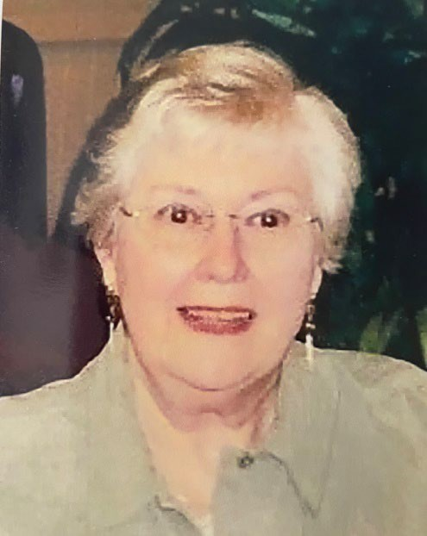
In memory of Beverly Ann (Dean)
Jarvis

October 23, 1931- January 8, 2012

Most of you know Beverly as a past president of CEPSA. She was a strong leader and ran meetings smoothly. Without question, she is the one of the most organized officers ever.
There is much more to know about this lovely woman. Beverly was born in Denton, Texas and raised in Fort Worth. She and her family moved to New Orleans when she was 11 years old. Unfortunately, this was during World War Il, so Mardi Gras was cancelled. In two years,

they moved to Memphis. Beverly did get to Mardi Gras, when her family returned to the Big Easy for a visit after the war ended.
Beverly's polio story began in November 1950, when she was a sophomore at Memphis State College (now University). She became sick on a Sunday night and was out of school all week. The doctor thought she had the flu. On Friday morning Beverly fell to the floor at home, when she attempted to stand up. She was carried to Baptist Hospital, where a spinal tap confirmed that she had polio. Beverly said she was medicated and "out of it" all weekend. The hospital staff placed her in isolation for about 10 days. Beverly recalled that she was moved upstairs on Thanksgiving Day. Family and friends came to visit. She was totally paralyzed, except for movement in her right arm. Another complication occurred when Beverly developed Bell's palsy after Thanksgiving weekend. Fortunately, this condition resolved by Christmas. Her doctors told her she was a "double oddity." She had polio in the fall, when more cases were diagnosed in the summer, and she developed Bell's palsy. During her hospital stay Beverly said she learned that all physical therapists are sadists. They placed hotpacks on her five times daily for 45 minutes each time. Initially the packs were very hot, and then they became very cold. Although she was moved out of isolation, Beverly remained in the "isolation hospital," where individuals with conditions such as tuberculosis and spinal meningitis were treated. She recalled that some people did not come to visit her because of the fear of getting polio. Beverly spent Friday afternoons painting figurines and still has some of them today.
A recovering Beverly went home in May 1951. She reenrolled in college in September, majoring in English. She returned to classes wearing two KAFOs and using crutches. She said it never occurred to her to get a wheelchair. Her classes met three days per week, and her mother drove her to school. Beverly recalls taking English and economics on the ground floor. Her other classes were on the second floor. The building had no elevators or ramps, so she could not get to those classes. The following year in the fall of 1952, the family moved to Montgomery, Alabama.
Around this time Dr. Campbell of Campbell's Clinic in Memphis referred Beverly to Warm Springs in Georgia. There she had muscle tests and lab tests. A very unhappy experience for her was being observed and discussed by the famous Dr. Robert Bennett and 15 other medical personnel seated in one large room. The team recommended a period of physical therapy. Beverly returned to Montgomery where she had PT three times weekly for four months. When she returned to Warm Springs, they found no improvement. Surgery on her left ankle was recommended for her left foot drop. Warm Springs surgeons performed a triple arthrodesis, which required several weeks of recovery there.
By this time Beverly had met the love of her life, Gene, and he drove from Fort Gordon to Montgomery and also to Warm Springs to visit her. One day they drove over to Talbotton, a small Georgia town near Warm Springs. They found an Episcopal church with an aqua-colored front door. Gene carried Beverly up the steps to the balcony, so she could pump the bellows and he could play the tracker organ. When she healed from her surgery, she went back to her job as secretary at the First Baptist Church in Montgomery.
The lovely couple was married in April 1955 at First Baptist. Gene recalled that his beautiful bride walked down the aisle using a white cane and holding her father's arm. They are the proud parents of two children, "who obtained adulthood by the grace of God," according to Beverly. On New Year's Eve 1964, she fell, broke both of her kneecaps, and required surgery at the Baptist Hospital in Montgomery. Their son Paul, who was almost three years old, really missed her mom. Paul rode his tricycle through a busy intersection and then rode down the street to the hospital. He rode his trike inside and sat down in a chair. When a nurse checked on him, he told her his name, and she called their home.
Gene rushed to the hospital for Paul. There was a big "coverup," because no one told Beverly until later about her son's boldness and determination to see her. Daughter Anne is younger than Paul. The family lived in Montgomery, except the two years spent in Tuscaloosa, Alabama, while Gene completed his graduate degree.

Beverly has worked at the Veterans Administration in several departments. She worked for Northwestern Mutual Insurance for five years. Now we know where she developed those excellent organizational skills.
It was Savannah's good fortune when the Jarvises moved here in 1984. Gene accepted a position as organist and choir director at First Presbyterian Church. Beverly began her art of quilting after arriving. This talented quilter has had three one-woman exhibitions—at the Arts Council Center in Vidalia, the Swainsboro Arts Center, and Armstrong College (now University). Beverly has won seven ribbons, including 1st place, Best of Show, and 2nd place in Atlanta for a quilt of Celtic design. This writer received a beautiful lap quilt of Celtic design, made by this talented lady, to commemorate my two years as CEPSA president. It is one of my greatest treasures.
The Jarvises speak proudly of their children. Paul is a corporate pilot for Regions Bank and lives in Birmingham. Emory, 16 years old, is the granddaughter. Anne works for Saks, Inc. in Jackson, Mississippi. She and her husband have assumed legal guardianship of his niece and nephew. So Beverly and Gene have kids to spoil.
Beverly's other interests have included singing in the choir and playing in the hand-bell choir in church since the 1970's. She reads a lot, enjoying mystery, suspense, and history.
As many of us did, Beverly took herself out of braces within three years after having polio. She continued using crutches and a cane. Her late effects of polio began in 1981. She "fell heir" to her father- in-law's wheelchair in the late 1980's and began µsing it because it was safer. Beverly recalled that her sister sent her an article about post-polio syndrome. In her polio archives she still has a copy of her surgery bill from Warm Springs.
Beverly recalls reading the local newspaper article in April 1997 about our beginning a post-polio support group. She attended the third meeting and became a lifer. We are so fortunate that this capable, talented woman came to CEPSA. As she does with everything, she has given total commitment. Beverly, your warm smile and kind voice help newcomers know they are in the right place. We salute you and offer you a long-overdue but rousing "THANK YOU FOR EVERYTHING!!"
By Cheryl Brackin

FROM OUR ARCHIVES: CEPSA Newsletter, April, 2001

FDR TURNED HIS TRAGEDY INTO TRIUMPH,AND THAT WAS A VERY GOOD THING
The Warm Springs Reunion sounds like a great event. I'm sure it has changed significantly since I was there for surgery in 1954. Dr. Bennett is surely gone. That darling "hunk" who worked in the brace shop and made the crutches I still use has probably moved on. Use of the various buildings and the layout have all changed . I remember the campus as spacious, quiet, green, and with a natural beauty. I remember my regret at having left one week before Eleanor Roosevelt visited. I had gone to Warm Springs for evaluation and recommendation as to what else could be done for me, and it was decided a triple arthrodesis on my left ankle, to correct drop foot, was about it. The more I think about the reunion, the more memories keep coming back. Some I had long forgotten.
…Going to dinner with my Mother and Gene and later being soundly castigated by a nurse's aide, who threatened to "tell the doctor" on me for eating the night before surgery!
… lovely dining room, white tablecloths, and really good food
… Meeting other polio survivors and being newly exposed to all the ways polio can affect various muscles and lives (besides my own)

… That awful annoying woman who talked non-stop from morning to night about how she managed to get up and down, in and out, over and under, in excruciating detail
… Going to movies in the new building with FDR in relief ( ? ) and the quote "We have nothing to fear but fear itself"
… Hearing Helen Hayes recite the 23rd Psalm on the stage before the movie. She wore a pink dress.
… Pushing myself in a wheelchair to the chapel, which was always open, getting a hymn book, hoisting myself on to the organ bench and playing away to my heart's content.
… Being sent to the resident psychologist, who was supposed to help me with any adjustment problems. She tried very hard but failed to get any problems out of me. I was engaged to be married and couldn't wait to get home and start planning my wedding a year in advance!
… Visits from my beloved who was then an Army Private, stationed at
Ft. Gordon, Georgia, and the time we drove to Talbotton to visit old Zion Church, where he carried me (and the leg cast) up the stairs to the balcony, where I pumped the bellows so he could play the antique "tracker" organ. But that's his story.
Patients at Warm Springs had as much independence as they were capable of handling. The attendants and medical personnel were always there for you, but the experience was what you made of it. That made for pleasant days and plenty of time to bond with others. I did not keep in touch with my new friends; they had lives to go back to and so did I.
My brief stay at Warm Springs was, at the time, an event to get through, put behind me, and get on with my life. Now, all these years later, I am grateful for the time spent there, for what it did for me, for the memories, but especially for what Franklin Roosevelt's vision and generosity in the midst of his own pain, and other crushing responsibilities, have done for all of us as survivors, whether we ever went to Warm Springs or not.
Thank you, Mr. President. Beverly Jarvis

**************************************************************************************

Thank you to our friends in the Boca Raton Polio Group who offer us their excellent ZOOM meetings on the second Thursday of each month from 12:00-2:00. Join us from the comfort of your home/office. If we do not have an email address for you, just send me a note with an email address from a family member who won’t mind sharing their computer with you occasionally. Maureen Sinkule, their president, welcomes polio survivors from all over the country and Canada. Download Zoom, “join a meeting”, and follow the prompts.

Thank you to our financial supporters in 2020-2022

Kenneth Tornvall Dan Shehan Richard Veccia Penny Smith Jan Schendorf Marty Foxx Sandra Bath Judy Frick Pebley Richard Graham Lillian Ellis
Lorraine Frew Anne Thompson Cheryl Brackin Casi Rainwater Fisher Eileen Boyle Mary Jane Morel Sommers Edward Jordan Lavonne Calandra Judy Melroy
Dr. Jules Paderewski Steven Beauvais Ron Gay Toby Hollenberg Joan Heidt Sharon Solomon Ayesha Swann-Brown Sidd Foster Robbie & Anna White Ron Stephens Bubba Daiss

Coastal Empire Polio Survivors Association, Inc. (CEPSA) is a non-profit 501(c)3 organization of volunteers, who are polio survivors. CEPSA began helping survivors more than 25 years ago to face Post- Polio Syndrome (PPS) which is unexpected with often disabling symptoms associated with the initial poliovirus contracted over forty years ago. There are approximately 2 million polio survivors still alive in America who had polio during the epidemics of the 1940's, 50's and early 60's. The need for our organization continues to grow, as more and more polio survivors find themselves confronting PPS, and needing accessible equipment and specialized health care.
Donations help our organization to offer essential post-polio health education to polio survivors through our support group meetings, newsletters and website, as well as providing guidance, emotional support and help with medical equipment. One of our past projects has been to purchase used scooters, motorized wheelchairs and lifts to help those in need in our group. Limited resources and physical energy issues with our aging members have curtailed our mobility assistance, but other agencies have taken up that work. The members of the Coastal Empire Polio Survivors Association, Inc. are dedicated to locating still more polio survivors and to enhancing the lives and independence of all polio survivors; to promoting public awareness of polio, post-polio syndrome, and polio immunizations, and to let the world know: "WE'RE STILL HERE!"

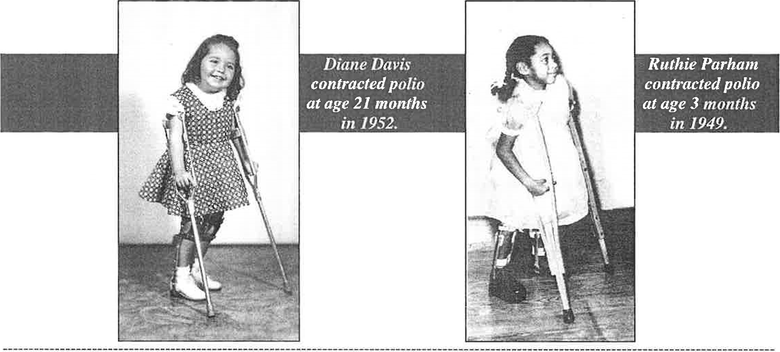

CONTRIBUTIONS
Your contributions are tax deductible and will be acknowledged appropriately. Please complete this form and mail with your check to: CEPSA, PO Box 14355, Savannah, GA 31405

Name Phone
Address E-mail
Polio survivor? Friend or relative?

Alphagraphics ad

Coastal Empire Polio Survivors Assoc., Inc.
P.O. Box 14355
Savannah, GA 31416 GA (912) 508-3470

